**Manuscript Title Bold 12 pt Times New Roman**

Author's name 1,* [](https://orcid.org/0000-0003-3515-4168) [](mailto:nas.abuhamoud@wau.edu.ly), Author's name 3[](https://orcid.org/0000-0002-9675-8304) [](mailto:nas.abuhamoud@wau.edu.ly), Author's name 4[](https://orcid.org/0000-0002-3468-3220) [](mailto:nas.abuhamoud@wau.edu.ly)

1 Affiliations of Authors: Department, Faculty, University, City, and Country

|  |  |  |
| --- | --- | --- |
| **ARTICLE HISTORY** |  | A B S T R A C T |
| Received Day Month Year  Revised Day Month Year  Accepted Day Month Year  Online Day Month Year  **KEYWORDS** | Time new Reman, size 9. The effects of dust aerosols on solar panels and people can occasionally extend thousands of kilometres across the atmosphere. The research aims to present the evaluation methods on the impact of dust accumulation on the performance of solar panels in the Libyan climate zone. The study conducted a series of experiments to measure the degradation of solar panel efficiency due to the deposition of dust on the surface of the solar panels. The presented results indicate that the accumulation of dust has a significant negative impact on the performance of solar panels, reducing their efficiency. Furthermore, the study listed the frequency and cleaning methods required to maintain the solar panels' performance over time in this harsh climate. The findings highlight the importance of routine cleaning and maintenance of solar panel installations in dusty and arid regions to ensure optimal performance and maximize energy efficiency. |
| Not less than 5 words;  No more than 7 words;  Dust impact;  Cleaning methods; Efficiency. |  |

**عنوان المخطوطة عنوان المخطوطة نوع الخط (Sakkal Majalla, 14, Bold)**

اسم المؤلف الاول 1،*، المؤلف الثاني 2، المؤلف الثالث 3 ((Sakkal Majalla, 12, Normal

|  |  |  |
| --- | --- | --- |
| **الكلمات المفتاحية:** |  | الملخص |
| ليبيا  ألواح الخلايا الشمسية  تأثير الغبار  طرق التنظيف  الكقاءة |  | نوع الخط (Sakkal Majalla, 10, Normal) تمتد تأثيرات الغبار على الألواح الشمسية والناس لآلاف الكيلومترات عبر الغلاف الجوي. يهدف البحث إلى عرض طرق تقييم تأثير تراكم الغبار على أداء الألواح الشمسية في ليبيا. أجرت الدراسة سلسلة من التجارب لقياس انخفاض كفاءة الألواح الشمسية نتيجة ترسب الغبار على سطح الألواح الشمسية. تشير النتائج المتحصل عليها إلى أن تراكم الغبار يقلل من كفاءة الواح الخلايا الشمسية. علاوة على ذلك، قدمت الدراسة عرضا لطرق التنظيف المتبعة للحفاظ على أداء الألواح الشمسية في المناخ الصحراوي. تسلط النتائج الضوء على أهمية التنظيف والصيانة الروتينية لمنظومات الألواح الشمسية في المناطق ذات العواصف الترابية لضمان الأداء الأمثل وتحقيق أقصى قدر من كفاءة الطاقة. |

**Introduction (main sections heads 12pt bold time new roman)**

Text (time new roman 10pt normal) Electrical power generation systems based on fired fossil fuels cause harm to the ecosystem and are considered the main cause of global warming and climate change. In Libya, the electricity generation sector is considered one of the most polluted sectors among all other sectors, as the CO2 emissions from the chimneys of electric power plants is about 34% of the country’s total CO2 emissions. [1].

measure the impacts on solar panels and present solutions [2].

**Libyan geography zone (subsections heads- 10pt bold time new roman)**

Libya is located in the North African region as figured out in

Figure 2, and it is a part of the northern hemisphere with 25° N and 17° E latitude and longitude affected by dust and some storms.

**Methodology**

The presence of dust in the air can negatively impact air quality by increasing levels of particulate matter, which can have adverse effects on respiratory health and reduce visibility [3]. If you are concerned about air quality in a specific location, it is recommended to check with local air quality monitoring agencies or authorities for more information. There are several methods for mitigating the impact of dust on PV performance as formulated in Table 2. Various software and tools can be used to track and mitigate the dust on the solar panels, one of them is MATLAB as presented in Figure 2.

Dust accumulation on solar Photovoltaic (PV) panels can significantly reduce their performance and efficiency [4]. Dust can have an insulating effect, reducing the amount of sunlight that reaches the solar cells and decreasing the amount of electricity produced [5].

In areas with high levels of dust or pollution, the impact can be even greater [6]. Therefore, it is important to regularly clean the solar PV panels to prevent dust buildup. Regular cleaning can help maintain optimal performance and increase the lifespan of the solar panels [6-12]. Additionally, it is important to choose a location for solar panels that is less prone to dust accumulation. In terms of gaining a sustainable environment, solar power is a great alternative to traditional sources of energy that rely on fossil fuels [13,14]. By reducing our reliance on fossil fuels and using clean,

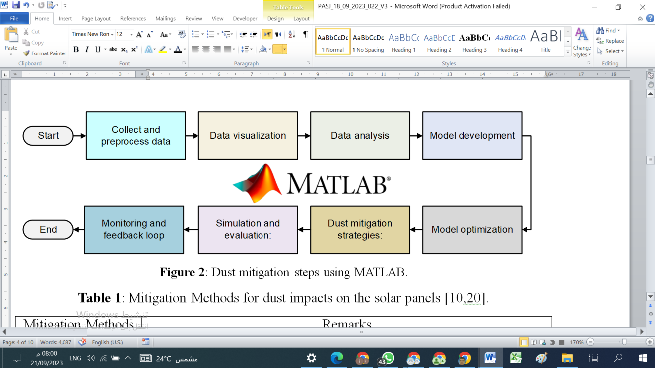

**Fig.3**: Time new roman 9 pt normal

**Table 2**: Monthly solar, wind, and temperature data analysis [22].

|  |  |  |  |
| --- | --- | --- | --- |
| **Months** | **Solar Irradiance (W/m2)** | **Wind Speed (m/s)** | **Temperature ($°$ C)** |
| **January** | 322 | 11.7 | 23 |
| **February** | 387 | 15.4 | 25.8 |
| **March** | 438 | 14.4 | 34 |
| **April** | 624 | 14.9 | 34 |
| **May** | 503 | 12.9 | 41 |
| **June** | 473 | 14.4 | 44.5 |
| **July** | 451 | 12.9 | 45.6 |
| **August** | 496 | 10.3 | 40.6 |
| **September** | 504 | 11.3 | 42.4 |
| **October** | 400 | 12.9 | 44 |
| **November** | 339 | 20.5 | 34 |
| **December** | 322 | 11.3 | 24 |

The first important term to be specified is dust, which can be summed up as tiny particles with a diameter smaller than 500 μm. It is made of solid substance, can be seen or unseen, floating or firmly planted [12]. To evaluate the impact of dust deposition on the solar panels, it is necessary to first determine how much dust accumulates on the panels [29]. We can define the thickness (*Td*) and volume (*Vd*) of dust on the solar panel which is defined by the formula that is mathematically expressed in Eq. (1) and Eq. (2).

|  |  |
| --- | --- |
| $$Td=\frac{volume of dust collected }{area of solar panel}$$ | (1) |
| $$Vd=\frac{mass of dust collected }{density of dust }$$ | (2) |

The majority of research publications quantify the amount of dust on the panel as grams per meter squared and calculate the power loss from the solar panel per gram of dust. Geographically, different amounts of dust collect on the panel. For instance, an Iranian experiment conducted in Tehran revealed that the dust concentration on a local solar panel (accumulated over the course of 70 days) ranges from 4.0599 g/m2 to 10.3129 g/m2. The rate of dust accumulation across the Middle East and North Africa was estimated to be about 0.3 g m-2 day [30]. If we contrast that figure with Tehran's, 0.3×70=21 g/m2, which is a reasonable amount given that these areas contain the largest quantities of dust on Earth [11].

**Disadvantages of dust**

The dust causes a negative impact, and some of the disadvantages of dust's impact on PV performance as tabulated in Table 3 [31]. Regular cleaning and maintenance can help mitigate the disadvantages of dust impacts on PV performance to ensure that the panels are generating as much energy as possible.

## Cleaning solar panels

To clean solar panels, there are a few well-known techniques. One of these involves the use of tractors with water-cleaning

wipers, brushes, and cleaning wipers, and is carried out by the Adani group in India [11]. However, the aforementioned method uses a lot of water and physical labor, which is both environmentally unsound and not profitable. Electrostatic dust removal is a different method of cleaning solar panels that uses a strong AC voltage to reject dust particles from dirty solar panels [32]. In the Middle East and North Africa, where dust accumulates over a period of three days, this has a maximum cleaning efficiency of 100% when the dust concentration is around 1 g/m2 [29].

**Author Contributions**: “Conceptualization, Name, Name and Name; methodology, Name and Name; writing—original draft preparation, review and editing, Name, Name and Name. All authors have read and agreed to the published version of the manuscript.”

**Funding**: “This research received no external funding.”

**Data Availability Statement**: “The data are available at request OR Not applicable.”

**Acknowledgments**: "The authors would like to express their appreciation to the Research Center for Renewable Energy and Sustainable Development, Wadi Alshatti University, Brack-Libya."

**Conflicts of Interest**: “The authors declare no conflict of interest."

**References**

[1] Y. Nassar, K. Aissa, and S. Alsadi, "Air Pollution Sources in Libya," *Research & Reviews: Journal of Ecology and Environmental Sciences*, vol. 6, no. 1, pp, 63-79, 2018. <https://doi.org/10.63318/waujpasv3i1_23>